%TRACE-E-TRACEBACK, symbolic stack dump follows  
%TRACE-E-TRACEBACK, symbolic stack dump follows  
image module routine line rel PC abs PC  
image module routine line rel PC abs PC  
0 FFFFFFFF8019BDB0 FFFFFFFF8019BDB0  
0 FFFFFFFF8019BDB0 FFFFFFFF8019BDB0  
LIBRTL LIB$CALLG LIB$CALLG 464 0000000000000072 FFFFFFFF8416D322  
LIBRTL LIB$CALLG LIB$CALLG 464 0000000000000072 FFFFFFFF8416D322  
DEC$FORRTL 0 0000000000062FA2 FFFFFFFF8520AFA2  
DEC$FORRTL 0 0000000000062FA2 FFFFFFFF8520AFA2  
DEC$FORRTL 0 0000000000107032 FFFFFFFF852AF032  
DEC$FORRTL 0 0000000000107032 FFFFFFFF852AF032  
DEC$FORRTL 0 00000000000FFE92 FFFFFFFF852A7E92  
DEC$FORRTL 0 00000000000FFE92 FFFFFFFF852A7E92  
ASFREP CSMONYI8 CSMONYI8 2805 00000000000005E2 00000000000D34D2  
ASFREP CSMONYI8 CSMONYI8 2805 00000000000005E2 00000000000D34D2  
ASFREP INVRPTSUB INVRPTSUB 8095 0000000000006021 00000000000B1931  
ASFREP INVRPTSUB INVRPTSUB 8095 0000000000006021 00000000000B1931  
ASFREP ASFREP ASFREP 5678 0000000000000B31 0000000000090B31  
ASFREP ASFREP ASFREP 5678 0000000000000B31 0000000000090B31

C:\Users\105864\AppData\Local\Microsoft\Windows\INetCache\Content.MSO\B45F260F.tmp

C:\Users\105864\AppData\Local\Microsoft\Windows\INetCache\Content.MSO\F0DEE9F5.tmp

Continuar a simular o teste do “double precision” se corresponde ao 8 bytes realmente o valor máximo talcomo é referido o REAL\*8

Correr o programa OLMCON e mandar a opção 7.

O volume de dados quer o seu montante que a quantidade de transações??

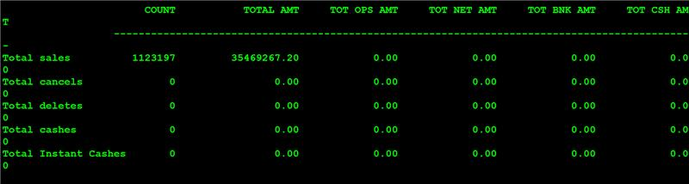

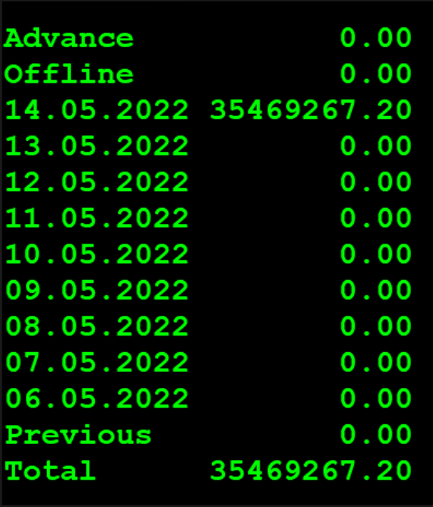

O ficheiro MTMF01.FIL está com o nome de MT7683.FIL;1 ou MT7684.FIL;1 confirmar (na maquina POSYSD no GXOLM)